**Terminal Structure:** Study this and runway orientation to determine what the algorithm should be for directing flights.

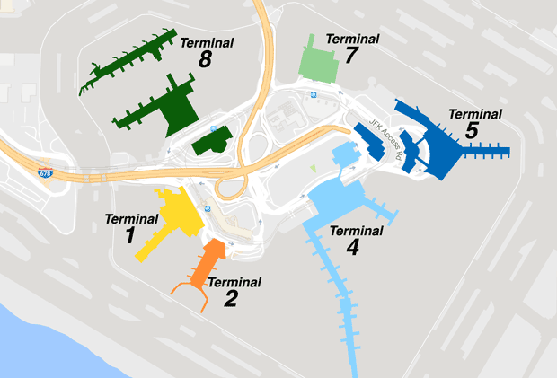

Taking in to account certain airlines to go only certain terminals using this website: <https://www.jfkairport.com/flight/airlines>. (Arrival and departure will from same terminal for an airline)

**Flight Data arrangement:** Looking through API’s to find the best way to get real time data about flights or generate our own historical data for the database part of the project.

After looking through many, top 3 choices which will be narrowed down to one soon:

* Aviationstack
* FlightAware
* OpenSky